**Name: HAMMAD TAHIR**

**Intern ID: TN/IN01/PY/006**

**Email ID : BEINGHAMMAD345@GMAIL.COM**

**Internship Domain : PYTHON**

**Task Week : 06**

**Instructor Name : HASSAN ALI**

**Task 1 :**

Use math & statistics libraries to get square roots and average.

**Solution:  
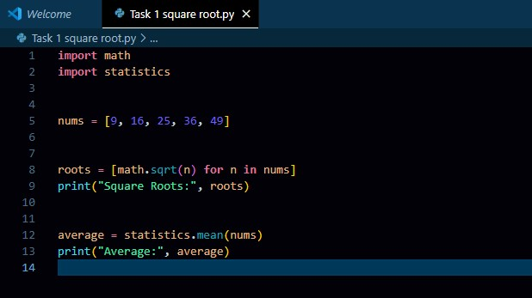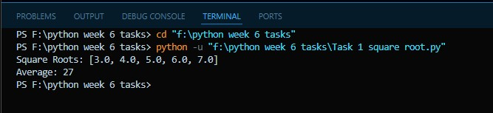**

**Task 2 :**

Create a custom package and import it in another script.

**Solution:**

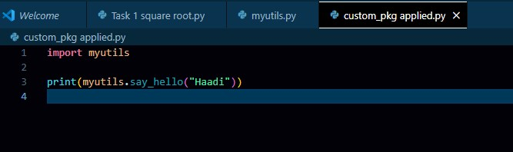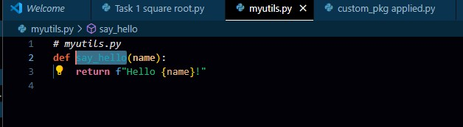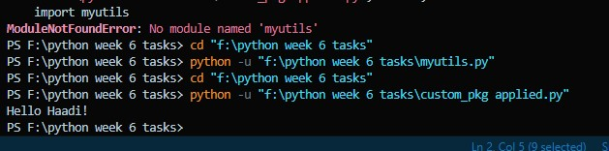

**Task 3 :**

Create a virtual environment, install requests & numpy, and print their versions.

**Solution:**

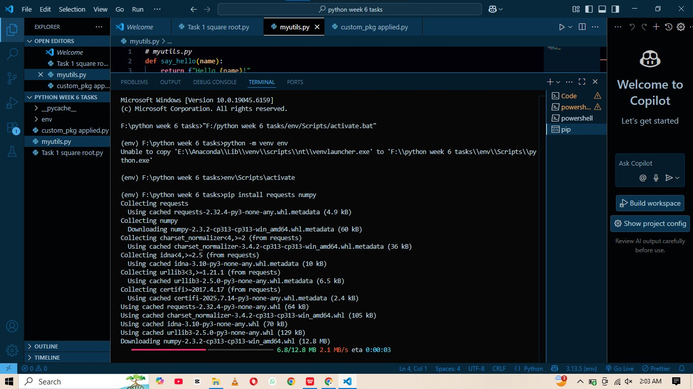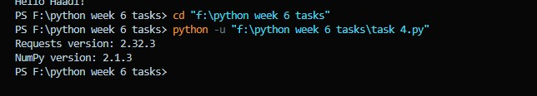

**Task 4 :**

Print list of all installed pip packages from Python code.

**Solution:**

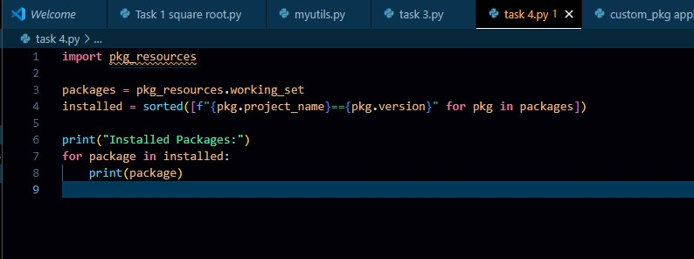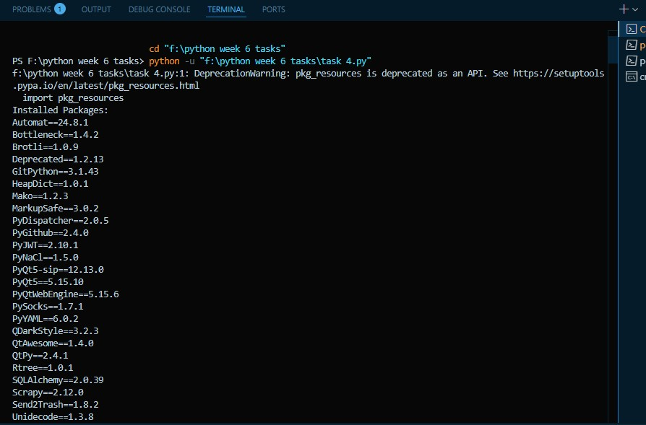

**Task 5 :**

Create Gradio app that takes a number and returns its square.

**Solution:**

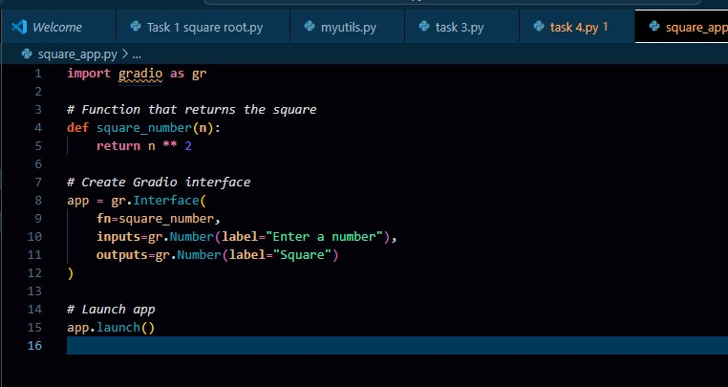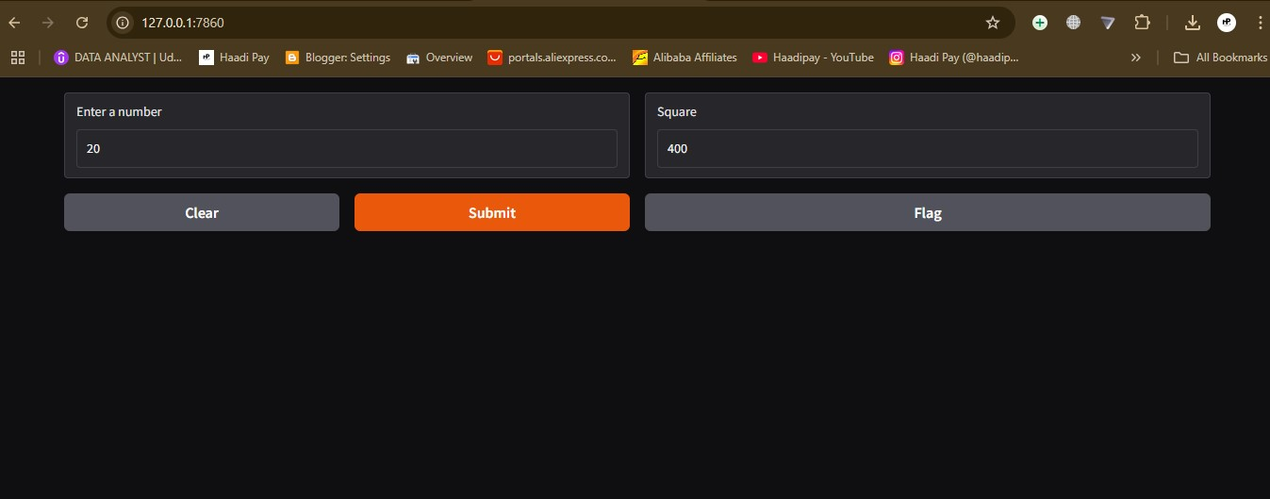

**Task 6 :**

Create Gradio interface that takes a sentence and returns it reversed.

**Solution:**

